Task No & Title: Unit 7 | Unit Descriptor Unit Descriptor This unit defines the competency required to configure, use and optimise a computer operating system.
Title: | Use computer operating system
Suitable for Classes: | Certificate II in Information Technology
Area: | Technology & Enterprise
Teacher: | Mr Peter Faulks
Timeline | 1 Lesson
Date Due: | Today

Task Brief:

Files Required

Items highlighted in yellow are tasks for you to complete
Items in Purple are help tips
Certificate II in Information Technology
Use computer operating system

1 | ICAU1128B Operate personal computer | Pre | 20 hours
2 | BSBCMN106A Follow workplace safety procedures | Core | 10
3 | ICAD2012B Design organisational documents using computing packages | Core | 40
4 | CAU2005B Operate computer hardware | Core | 20
5 | ICAU2006B Operate computing packages | Core | 60
6 | ICAU2013A Integrate Commercial computing packages | Core | 25
7 | ICAU2231B Use computer operating system | Core | 20
8 | ICAW2001B Work effectively in an IT environment | Core | 25
9 | ICAW2002B Communicate in the workplace | Elective | 20
10 | ICAS2014B Connect Hardware Peripherals | Elective | 25
11 | ICAU2007B Maintenance of equipment and consumables | Elective | 15
12 | ICPMM263B Access and use the internet | Elective | 20
13 | ICAW2011B Work individually or as a team member | Elective | 20
14 | ICPMM321B Capture a digital image | Elective | 30

Explain the following computer Peripherals (100 Marks)

1. Screen

3 marks
2. Keyboard

3 marks

3.Mouse

3 marks

4.System Unit
4 marks

5.Central Processing Unit
3 marks

6.Memory
3 marks

7.Sound Card
3 marks

Explain the following computer peripherals:

8.A Printer is…
5 marks

9.A Scanner is used to
5 marks

10.A Modem allows you to…
5 marks

11. Explain the difference between a CD-R, CD-RW, DVD-R and DVD-RW
5 marks

12 Explain an Ergonomic principle to help avoid eye strain
5 marks

13 Explain an Ergonomic principle to help avoid physical strain.
5 marks

14 Describe the function of a computer operating system.
5 marks
15 Describe the boot process.
5 marks

16. What is the relationship between an application program, the operating system and hardware?
5 marks

17. What are the general differences between the different computer platforms and their respective operating systems.
5 marks

18. Draw a simple block diagram showing the interconnection of the various components of a computer.
Answer:

5 marks

19. Write the name of the external hardware components and peripherals on the following diagram
Answers:
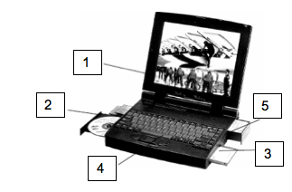

1.
2.
3.
4.
5.
5 marks

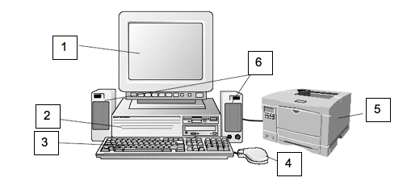

20. Label the parts on these computers
Answers:
1.
2.
3.
4.
5.
6.
5 marks

21. Describe the functions of computer hardware and associated OH&S standards and environmental considerations around hardware use and disposal of equipment

5 marks

22. Label each of the following as hardware or software.

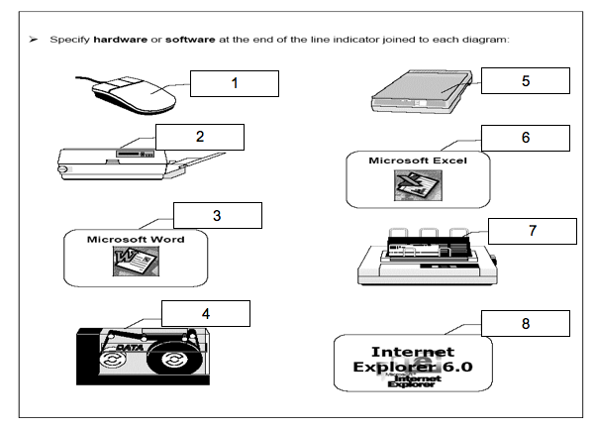
Answers must be detailed:
1.

2.

3.

4.

5.

6.

7.

8.

8 marks

END of Quiz

Save the work

Student Name: | Date submitted:
I declare this evidence to have been produced by me the undersigned.

Candidate’s signature:
Title of Portfolio evidence presented (include Unit No and section i.e. 03.05)
:-
□ Outcomes from learning programs (including self-learning and online learning)
□ Assessment feedback (from a trainer or assessor)
□ Observation checklists (from a workplace supervisor or assessor)
□ Written statements or references (including workplace supervisors, community leaders)
□ Job descriptions
□ Work journal
□ Work samples
□ Finished products
□ Product descriptions or specifications (supporting the product samples included)
□ Statutory declarations
□ List others (or delete any from above not provided)
- All work submitted to be word processed and spell checked.
- There must be at least two samples of evidence for each
Element within the Unit of Competency. This is sample 1 / 2
- All work submitted must be of a high quality and meet the
requirements of the Unit of Competency.
Other evidence (List each piece):
Assessor to complete
Evidence is Valid Sufficient Authentic Current
□ □ □ □

Assessor signature: _________________________________Date: _____________
Peter Faulks, BA Soc Sci, Grad Dip Ed, Cert IV AWT
Certificate II in Information Technology assessor/teacher
Assessor to complete

Student is declared Competent Not Yet Competent
□ □

Keep a copy of this report with your file for evidence

